Assignment 2: Resilient Architecture with Route 53 Bulkhead Monitoring Health Checks and Routing

You are a Cloud Architect working for an e-commerce company. Your task is to design a resilient architecture that includes Route 53 bulkhead monitoring health checks and routing to ensure high availability of the application.

## Tasks:

1. Identify the critical components of the e-commerce application and their dependencies.
2. Identify the requirements for high availability, including recovery time objectives (RTO) and recovery point objectives (RPO).
3. Design a Route 53 bulkhead monitoring solution that includes health checks and routing to ensure high availability of the application.
4. Determine the appropriate health check interval and time-out value for each component of the application.
5. Implement the health checks and routing using Route 53.
6. Test the health checks and routing to ensure that they are working as expected.
7. Identify any issues or potential failures in the health check and routing solution and develop a plan to address them.
8. Document the Route 53 bulkhead monitoring solution, including the health check configuration and routing policies.

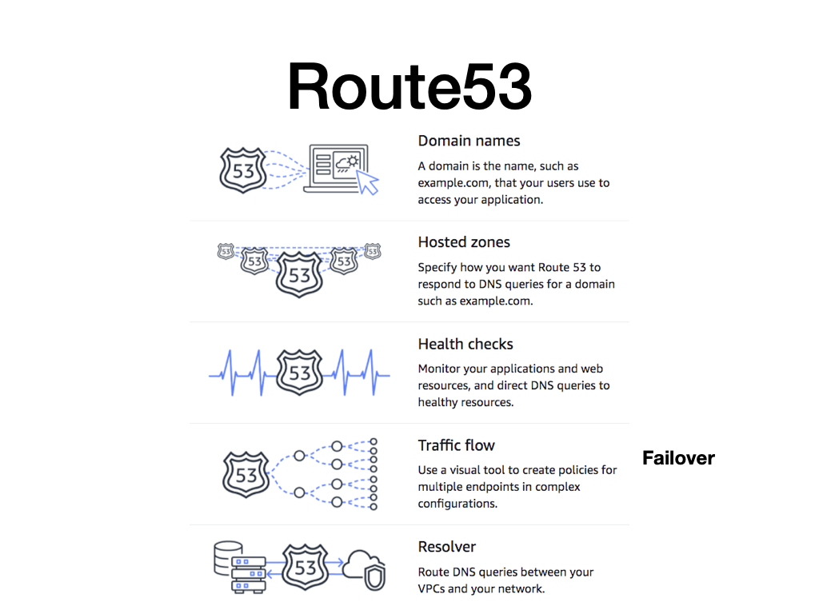

## Checklist:

* Identify the critical components of the e-commerce application and their dependencies:
  + What are the critical components of the e-commerce application?
  + What are the dependencies between the components?
* Identify the requirements for high availability, including recovery time objectives (RTO) and recovery point objectives (RPO):
  + What are the RTO and RPO requirements?
  + How much downtime can be tolerated for each component?
* Design a Route 53 bulkhead monitoring solution that includes health checks and routing to ensure high availability of the application:
  + What is the architecture of the Route 53 bulkhead monitoring solution?
  + How will the solution ensure high availability of the application?
* Determine the appropriate health check interval and time-out value for each component of the application:
  + What is the appropriate health check interval for each component?
  + What is the appropriate time-out value for each component?
* Implement the health checks and routing using Route 53:
  + How will the health checks and routing be implemented using Route 53?
  + What are the steps to configure health checks and routing in Route 53?
* Test the health checks and routing to ensure that they are working as expected:
  + How will the health checks and routing be tested?
  + What are the criteria for determining whether the health checks and routing are working as expected?
* Identify any issues or potential failures in the health check and routing solution and develop a plan to address them:
  + What are the potential issues or failures in the health check and routing solution?
  + How will they be addressed if they occur?
* Document the Route 53 bulkhead monitoring solution, including the health check configuration and routing policies:
  + What should be included in the documentation of the Route 53 bulkhead monitoring solution?
  + How should the health check configuration and routing policies be documented?

## Example

An e-commerce company that sells clothing online has a website hosted on AWS and uses Route 53 for DNS management. The website experiences a sudden surge in traffic during a holiday season sale, causing the website to slow down and some customers to experience errors while trying to place orders. The company realizes that they need a more resilient architecture to handle spikes in traffic and prevent such issues from occurring in the future.

To address this issue, the company decides to implement a Route 53 bulkhead monitoring health checks and routing strategy. They plan to divide their customer traffic into two different sets:

1. **Priority traffic:** This traffic is reserved for customers who have items in their cart and are in the process of checking out. This traffic needs to be given the highest priority and should always be routed to healthy and available servers.
2. **Non-priority traffic:** This traffic includes customers who are browsing the website or adding items to their cart but have not yet started the checkout process. This traffic can be routed to servers that are experiencing some latency or are not completely healthy.

To implement this strategy, the company first sets up health checks on their servers using Route 53. These health checks monitor the health of the servers and report back to Route 53 whether the servers are healthy or not.

Next, they set up Route 53 health checkers to monitor the health of their website's endpoints, such as the checkout page and the login page. If an endpoint fails a health check, Route 53 will mark the corresponding server as unhealthy and remove it from the pool of available servers.

Finally, they configure their DNS settings in Route 53 to use a bulkhead strategy. They divide their customer traffic into the two categories mentioned above and configure Route 53 to route the priority traffic to healthy servers first. If all healthy servers are busy with priority traffic, Route 53 will start routing non-priority traffic to other available servers.

With this strategy in place, the e-commerce company is able to ensure that their customers can always complete their purchases, even during periods of high traffic. The bulkhead strategy ensures that priority traffic always gets through, while non-priority traffic can be routed to other available servers if necessary. Additionally, the health checks ensure that only healthy servers are used, minimizing the risk of downtime or errors.

## Steps to design Route 53

1. Define the use case scenarios: Identify the different scenarios that require route 53 bulkhead monitoring health checks and routing for the e-commerce company. For example, scenarios where there is high traffic on the website, during peak sale season, or during new product launches.
2. Set up Route 53 health checks: Configure Route 53 health checks to monitor the health of the backend services, such as the application load balancers or web servers. This will help to detect any failures or latency issues in the backend services.
3. Configure Route 53 routing policies: Set up routing policies in Route 53 to direct traffic to the healthy backend services. Use routing policies such as failover routing, weighted routing, or latency-based routing to ensure that traffic is directed to the best performing backend service.
4. Implement Route 53 bulkhead: Use Route 53 bulkhead to limit the number of requests that are sent to the backend services. This will help to prevent the backend services from being overwhelmed with too many requests, and will improve the overall performance of the system.
5. Monitor Route 53 health checks: Continuously monitor the Route 53 health checks to detect any issues with the backend services. Use CloudWatch to set up alarms and notifications to alert the team when there are any issues detected.
6. Configure Route 53 DNS failover: Set up DNS failover in Route 53 to automatically route traffic to a backup endpoint in case of a failure in the primary endpoint. This will ensure that the e-commerce website remains available to users even in the event of a failure.
7. Monitor and test the system: Regularly test the system to ensure that the Route 53 bulkhead monitoring health checks and routing is working effectively. Use load testing tools to simulate high traffic scenarios and ensure that the system is able to handle the load.
8. Continuously improve the system: Continuously monitor and analyze the performance of the system to identify areas of improvement. Use the insights gained from the monitoring to make adjustments and improvements to the system to ensure that it remains resilient.
9. Review and update the system: Regularly review and update the system to ensure that it remains aligned with the business requirements and any changes in the technology landscape. Ensure that the system is kept up-to-date with the latest security patches and updates to prevent any security vulnerabilities.